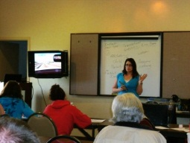

DRIVER IMPROVEMENT CLASSES

SAVE $15.00

WHEN YOU PRE-PAY ONLINE

(Payment must be received by Thursday prior to the Saturday class)

www.Drivereducate.com VISA/MC/DISCOVER/PAYPAL
INTERESTING! INTERACTIVE! INFORMATIVE!
YOU MAY BE REQUIRED TO TAKE THE CLASS…BUT WHO SAYS YOU GOTTA BE BORED TO TEARS?

DRIVEREDUCATE.COM OR TEXT
540-241-0901

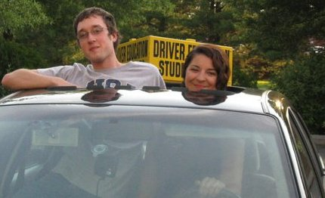
Instructor, Dawn Hollingsworth
- Former Police Officer & DCJS Trainer
- JMU Graduate
- Air Force Veteran

CLASSES HELD IN WAYNESBORO. VISIT WEBSITE OR TEXT FOR LOCATION UPDATES AS THE LOCATION CHANGES FROM TIME TO TIME. WWW.DRIVEREDUCATE.COM
(Class is usually held at our main office Behind King Photo/inside Security Training Concepts)
1025 B. W. Main Street Waynesboro, VA 22980
- DMV CERTIFIED OVER 12 YEARS
- COURT APPROVED
- EARN UP TO 5 POINTS
- VETERAN OWNED BUSINESS
- LOCALLY OWNED

